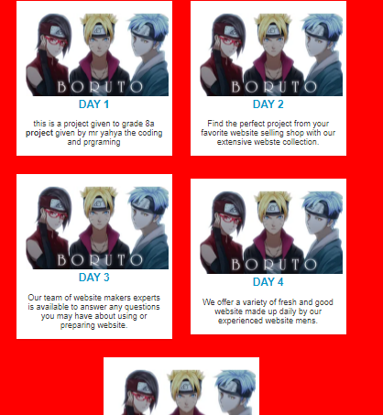

This website is all about website that these people made which they sell the website are of high quality you can buy and put whatever you want and you can change some things if you want the website are made by expertise.